Jasmina Durmishi – Sequence Diagrams
SC_27 - Send Due Date Reminder:
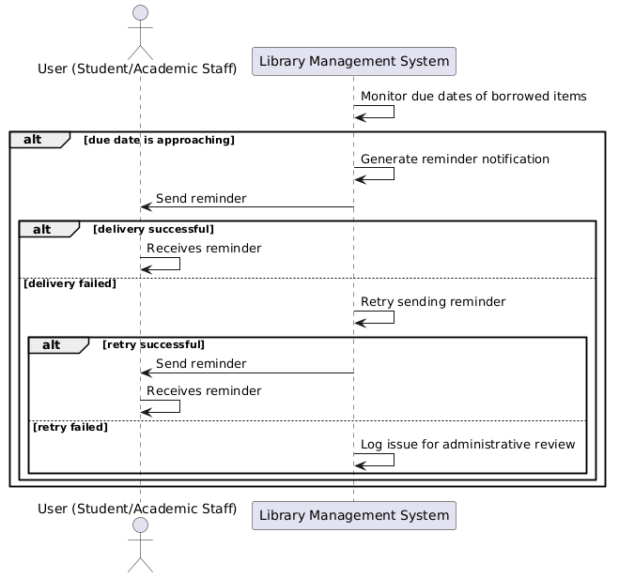

SC_28 - Send Overdue Notification:
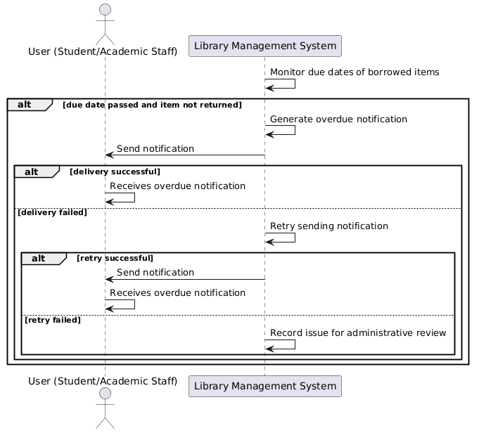

SC_29 - Send Borrowing Confirmation:
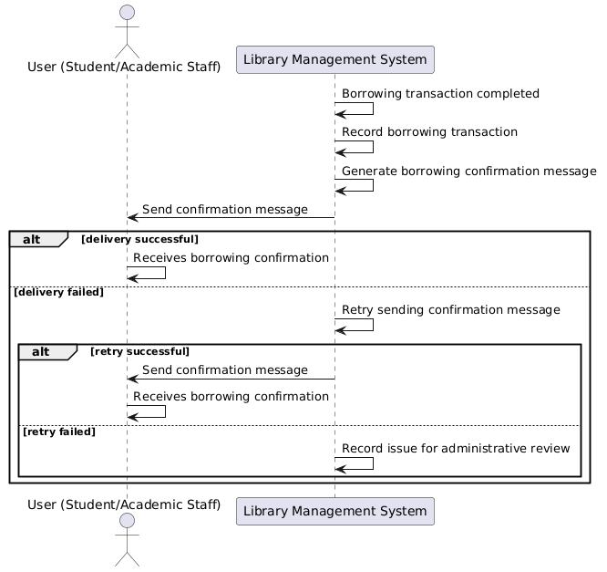

SC_30 - Send Return Confirmation:
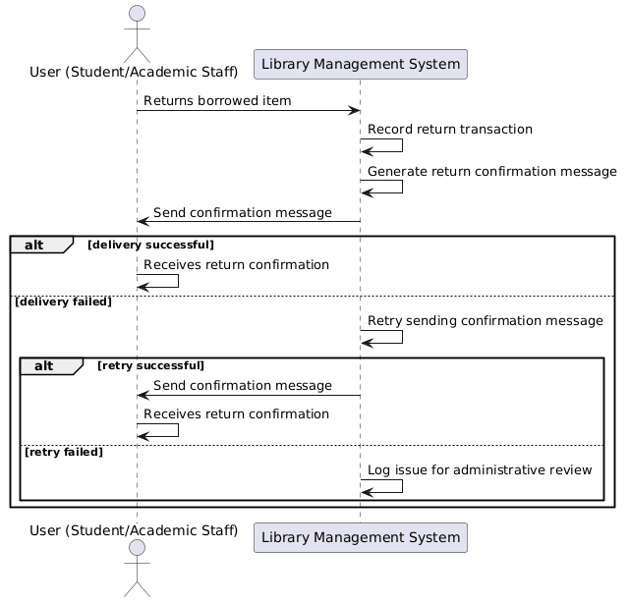

SC_31 - Send Fine Notification:
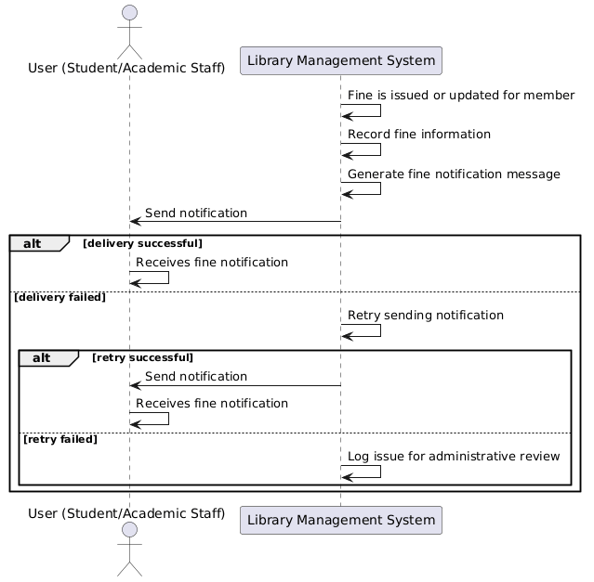

AC_LMS_32 - Deliver Alerts and Announcements:
